HealthHub Connect

## A PROJECT REPORT

***Submitted by,***

**CHANDANA P - 20201CSE0553**

**NAVEEN KUMAR B S - 20201CSE0587**

**KISHORE KUMAR R - 20201CSE0592**

**NIVEDITA - 20201CSE0572**

**TEJASWINI P - 20201CSE0546**

***Under the guidance of,***

**Mr. Ramesh T**

***in partial fulfillment for the award of the degree of***

# BACHELOR OF TECHNOLOGY

## IN

**COMPUTER SCIENCE AND ENGINEERING**

**At**



# PRESIDENCY UNIVERSITY BENGALURU JANUARY 2024



**PRESIDENCY UNIVERSITY**

**SCHOOL OF COMPUTER SCIENCE AND ENGINEERING**

**DECLARATION**

We hereby declare that the work, which is being presented in the project report entitled **HealthHub Connect** in partial fulfilment for the award of Degree of **Bachelor of Technology** in **Computer Science and Engineering**, is a record of our own investigations carried under the guidance of **Mr. Ramesh T, Assistant Professor,** **School of Computer Science and Engineering, Presidency University, Bengaluru.**

We have not submitted the matter presented in this report anywhere for the award of any other Degree.

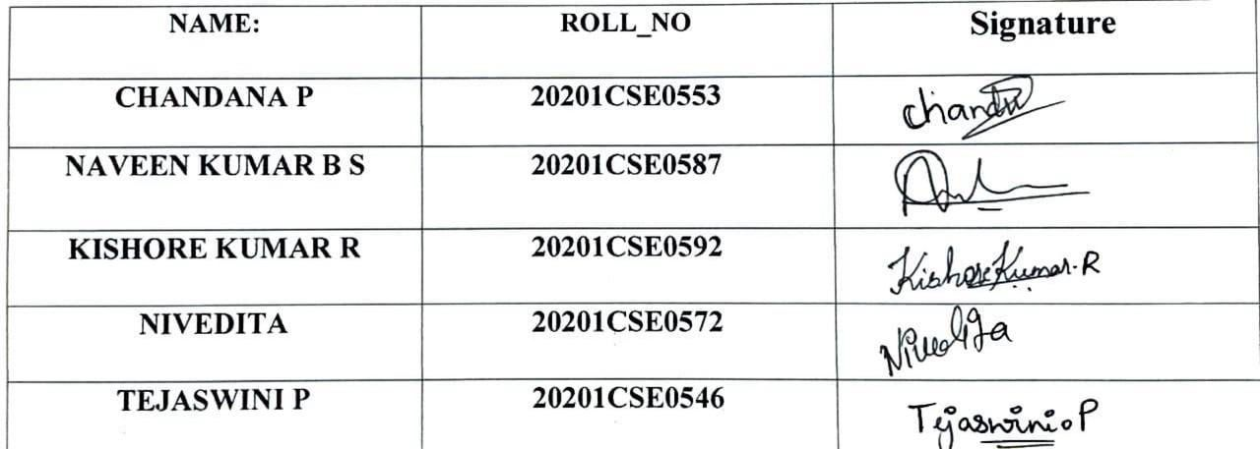

**ABSTRACT**

Technology integration is now essential in the changing healthcare landscape to promote better patient outcomes and more efficient healthcare delivery. The idea of a state-of-the-art healthcare portal that aims to improve overall healthcare coordination and change the patient experience is presented in this abstract.

In order to create a safe and convenient online environment for patients, healthcare professionals, and administrators, our suggested healthcare portal acts as a primary hub. The main goals of the site are to empower patients by providing them with simple access to their medical records, to foster effective communication between stakeholders, and to enable proactive health management.

The portal includes capabilities for medication management, telehealth integration for virtual consultations, and a powerful appointment scheduling system. It ensures a full view of patient information by smoothly integrating with current healthcare systems, prioritizing interoperability. Collaborative care planning and coordination are fostered by the use of a secure messaging platform to improve communication between healthcare providers.

Patients are encouraged to actively participate in preventive care by the portal's abundance of wellness and health tools in addition to personalized health data. Continuous improvement is made possible by the deployment of data analytics tools, which offer insights into user behavior and healthcare outcomes to inform strategic improvements.

Security and compliance are paramount, with the portal designed to adhere to healthcare regulations such as HIPAA. This commitment to data security ensures the confidentiality and integrity of patient information, building trust among users.

By putting patients at the center of their treatment journey and maximizing coordination and communication among healthcare professionals, our goal with this cutting-edge healthcare portal is to completely transform the healthcare experience.

This abstract lays the groundwork for a thorough examination of the features, development,

and possible effects on the healthcare industry of the portal.

# 

# ACKNOWLEDGEMENT

First of all, we indebted to the **GOD ALMIGHTY** for giving me an opportunity to excel in our efforts to complete this project on time.

We express our sincere thanks to our respected **Dr. Md. Sameeruddin Khan**, Dean, School of Computer Science and Engineering & Information Science, Presidency University for getting us permission to undergo the project.

We record our heartfelt gratitude to our beloved Associate Deans **Dr. Kalaiarasan C and Dr. Shakkeera L,** School of Computer Science and Engineering & Information Science, Presidency University and **Dr. PALLAVI R**, Head of the Department, School of Computer Science and Engineering, Presidency University for rendering timely help for the successful completion of this project.

We are greatly indebted to our guide **Mr. RAMESH T, Professor**, School of Computer Science and Engineering, Presidency University for his inspirational guidance, and valuable suggestions and for providing us a chance to express our technical capabilities in every respect for the completion of the project work.

We would like to convey our gratitude and heartfelt thanks to the University Project-II Coordinators **Dr. Sanjeev P Kaulgud, Dr. Mrutyunjaya MS** and also the department Project Coordinators **Mr. Zia Ur Rahman , Mr. Peniel John Whistely.**

We thank our family and friends for the strong support and inspiration they have provided us in bringing out this project.

Chandana P (20201CSE0553)

Naveen Kumar B S (20201CSE0587)

Kishore Kumar R(20201CSE0592)

Nivedita (20201CSE0572)

Tejaswini P (20201CSE0546)

# TABLE OF CONTENTS

|  |  |  |
| --- | --- | --- |
| **CHAPTER NO.** | **TITLE** | **PAGE NO.** |
|  | **ABSTRACT**  **ACKNOWLEDGMENT** | **iv**  **v** |
| **1.** | **INTRODUCTION** | **8** |
| **2.** | **LITERATURE REVIEW** | **13** |
| **3.** | **RESEARCH GAPS OF EXISTING METHODS** | **21** |
| **4.** | **PROPOSED METHODOLOGY** | **22** |
| **5.** | **OBJECTIVES** | **25** |
| **6.** | **SYSTEM DESIGN AND**  **IMPLEMENTATION** | **26** |
| **7.** | **TIMELINE FOR EXECUTION OF**  **PROJECT** | **29** |
| **8.** | **OUTCOMES** | **32** |
| **9.** | **RESULTS AND DISCUSSSION** | **34** |
| **10.** | **CONCLUSION** | **35** |
| **11.** | **REFERENCES** | **36** |
| **12.** | **APPENDIX-A PSUEDOCODE** | **37** |
| **13.** | **APPENDIX-B SCREENSHOTS** | **45** |
| **14.** | **APPENDIX-C ENCLOSURES** | **53** |

# LIST OF FIGURES

Use Case Diagram 27

Timeline Gantt chart 32

Home page 45

Admin login page 45

Admin login pade code 46

Admin logout page 46

Admin logout page code 47

Doctor login page 47

Doctor login page code 48

Hospital records page 48

Hospital records page code 49

Hospital registration form page 49

Hospital registration form code 50

Nurse login page 50

Nurse login page code 51

Nurse records page 51

Nurse records page code 52

# CHAPTER-1

# INTRODUCTION

The project Hospital Management system comprises computerized billing in the labs and pharmacy, as well as patient registration and data storage. Every patient can have a unique ID assigned to them by the software, which also automatically saves all of the patient and staff information. It has a search function to find out each room's current condition. Using the ID, the user can look up a doctor's availability and a patient's data.

With a login and password, one can access the Hospital Management System. An administrator or a receptionist can access it. The database can only contain data that they add. It is simple to retrieve the data. It has an extremely user-friendly interface. The data processing is incredibly quick and is well-protected for personal usage.

Hospital Management System was created with the intention of providing hospitals with tangible, imaginable benefits. It is strong, adaptable, and simple to use.

A comprehensive range of hospital administration and management tasks are covered by the Hospital Management System, which is intended for multispecialty institutions. It is a seamless, integrated end-to-end hospital management system that gives pertinent data to help efficient decision-making for patient care, hospital administration, and vital financial accounting.

A software suite called Hospital Management System is intended to enhance hospital management in the domains of clinical process analysis and activity-based costing. With the help of the Hospital Management System, you can grow your company and raise the productivity and caliber of your output. Effectively managing the hospital's essential processes is essential to its success and aids in process management.

## Aim of Project

HealthHub Connect is all about developing an healthcare care portal app that helps an individual to search for an hospital or a doctor to consult their illness.

## Project Overview

## The undertakings covered by the Health Center Program project budget are specified in the scope of work for a health center. The permitted service sites, services, providers, service area(s), and target population(s) are specifically defined under the project scope. This webpage offers guidance on precisely recording the project's scope and notifying HRSA of a change in scope (CIS) request when deemed necessary.

## Project Modules

## There are seven key modules that make up the complete project:

1. The admin module
2. Patient user module
3. Physician user module
4. Nurse Work Module
5. The module for pharmacists
6. The module for lab technicians
7. Module for account
   * 1. **Module for administration:**
8. observe doctor appointments.
9. oversee the hospital department's user, physician, nurse, pharmacist, and laboratory accounts.
10. observe the patient payment transaction reports.
11. Status of beds, wards, and cabins.
12. observe blood bank report.
13. observe hospital stock status of medications view the birth, diagnosis, and death reports.
14. View the operation report.
    * 1. **Patient user module:**
15. View the doctor's appointment schedule and status.
16. See the specifics of the prescription.
17. View the doctor's prescription.
18. See the list of doctors.
19. Check the status of the blood bank.
20. Examine the history of operations.
21. View the history of admissions. like a bed, an ICU ward, etc.
22. Control your own profile.
    * 1. **Module of doctors:**
23. Organize patients.
24. create and update accounts.
25. Establish and oversee a patient appointment.
26. Make a prescription for the patient and give them medicine Concerns patient operations and generates an operation report.
27. Control your own profile.
    * 1. **Module for nurses:**
28. Organize patients.
29. Create and update accounts.
30. Give patients a bed, ward, or cabin.
31. As directed by the patient, administer medication.
32. Oversee the blood bank and provide status updates.
33. Record patient procedures, births, and deaths.
34. Maintain personal profile.
    * 1. **Module on Pharmacists:**
35. Maintaining medication.
36. Maintain data on hospital medication inventories and status Control the classifications of medications.
37. Observe the patient's prescription and administer medication as directed.
    * 1. **Module for Laboratorists:**
38. Observe the prescription list.
39. Provide a diagnostic report.
40. Preview of report files such as MRI results, CT scans, and xray pictures.
41. Control your own profile.
    * 1. **Module for Accountants:**
42. Make a bill of sale for payment.
43. Send the patient an order invoice.
44. Accept cash.
45. Examine the patients' payment history.
46. Control your own profile.

## 1.3Project Requirements:

## HARDWARE REQUIREMENTS:

Hardware, or physical computer resources, is the most frequent collection of requirements defined by any operating system or software program. A hardware compatibility list (HCL), particularly when it comes to operating systems, is frequently included with a hardware requirements list. Hardware devices tested for compatibility and occasionally incompatibility with a specific operating system or application are listed in an HCL. Subsections that follow go over the many facets of hardware requirements.

Hardware requirements for present project:

* Processor: intel dual core ,i3
* Ram: 1 gb
* Hard disk: 80 g

## SOFTWARE REQUIREMENTS:

## The term "software requirements" refers to the specifications of software resources and prerequisites that must be installed on a computer in order for a program to operate as well as possible. Before installing the software, these prerequisites must be installed individually as they are typically not part of the software installation package.

## Software requirements for present project:

## Operating system: windows 7/ xp/8.

## Front end: html,css,javascript.

## Server side script: php

## Database: Mysql

**CHAPTER-2**

**LITERATURE REVIEW**

The term "mHealth," or "mobile health," refers to a global phenomenon that has attracted a lot of interest in the last 10 years. In order to assist people achieve their health objectives, mobile technologies—such as smartphones, software programs, and gadgets—are combined in the rapidly developing field of mHealth. Global health service delivery could change if mobile and wireless technologies are adopted in the healthcare industry. The aforementioned achievements have played a role in this shift: Considerations include the tendency of incorporating mobile health solutions into institutional health systems, the quick development of mobile networks and applications, and the rise in funding, legislation, and supporting data.

mHealth is considered as a component of eHealth. However, there isn't currently a consensus definition of mHealth. mHealth is defined by the WHO Global Observatory for eHealth (GOe) as:

“Medical and public health practice supported by Mobile devices, such as mobile phones, patient monitoring devices, personal digital assistants (PDAs), and other wireless devices. mHealth involves the use and capital ization on a mobile phone’s core utility of voice and short messaging service (SMS) as well as more complex functionalities,”

One of the industries that is growing the fastest and liveliest right now is health technology. Innovative technologies like remote monitoring and virtual consultations are being used by healthcare organizations to increase patient access, reduce costs, and enhance patient outcomes. Consequently, investors who wish to make investments in healthcare technology that has the potential to upend the current healthcare system are showing a lot of interest.

The majority of funding this year is probably going to go to digital health businesses due to growing investment in the healthcare industry.

In a setting where introducing healthcare technology solutions is getting easier, investors and innovators in healthcare software development anticipate that the quantity of agreements and total amount of money invested will create new records.With a 25% compound annual growth rate, the

worldwide digital health industry is projected to be valued $660 million by 2025.

With smartphones quickly becoming an extension of our lives in today's technologically advanced world, a fascinating trend of mHealth apps has gained huge appeal, enabling people to take charge of their well-being like never before. Therefore, it is not surprising that by 2020, businesses and investors in digital health would have spent over $21 billion on these initiatives.

There were over 52,565 healthcare apps on the Google Play Store and 51,370 apps on the Apple App Store in the first quarter of 2022, according to Statista. Since the COVID-19 epidemic began, the number of downloads for healthcare apps has increased by 60% globally.

This is a comprehensive analysis of research studies that were published in science between 2012 and 2016. This review's phases adhered to a predetermined procedure in order to preserve methodological and scientific rigor, specifically:

1. Detailed formulation of the research query.
2. defining the parameters for research inclusion and sample selection (search or sampling), including literature sampling.
3. a table-style representation of the study that takes into consideration all of the commonalities (data collection).
4. a thorough review of the publications on the list, pointing up contradictions and differences.
5. Analysis and discussion of the findings.
6. Clearly and impartially integrated presentation review, using data and supporting evidence.

**2.1 Methods for developing health care portal:**

**2.1.1 Systems Development Life Cycle**

A methodical and well-defined strategy to helping software engineers produce high-quality software is the Software Development Life Cycle (SDLC). Planning, designing, developing, testing, deploying, and maintaining are among the other steps it includes. Although SDLC offers a lot of benefits, it also has certain disadvantages.

Advantages:

* Organized Approach: The Software Development Life Cycle (SDLC) gives software engineers the capacity to plan and organize their work more effectively. This tactic also guarantees software delivery on time, boosts productivity, and lowers mistake rates.
* Risk Management: Software Development Life Cycle (SDLC) assists in identifying and controlling risks related to software development. Moreover, potential risks can be reduced by identifying and mitigating them, which lowers the software development risk overall. can mitigate them, lowering the overall risk of software development.
* Consistency: By providing a standard framework and procedure, the SDLC promotes consistency in software development. Moreover, consistency ensures that the final result meets the client's expectations and contributes to the improvement of software quality.
* Collaboration: The SDLC fosters teamwork by providing participants with a standard application structure and language for communication. This collaboration ensures that the finished product meets the client's requirements and advances the program as a whole.
* Cost-Effective: By using prototype tools like Figma and other programs, the SDLC assists in identifying issues early in the development process, which lowers development expenses. Moreover, early vulnerability detection allows engineers to mitigate the risk.It brings down the total cost of the development.
* Encourages open communication within the workplace, assigns suitable tasks to staff, and enhances collaboration and coordination.
* There is very minimal risk when the work is done.
* A unified vision for the product that all parties can support.

Disadvantages:

* Time-consuming: The SDLC may take a while if the development process is intricate. If this causes a delay in the delivery of the software, clients may grow irate.
* Inflexibility: If needs change while the project is being created, the SDLC could not be flexible enough. This inflexibility could result in a finished product that isn't up to the client's standards.
* The Software Development Life Cycle (SDLC) demands a significant initial investment of time, money, and resources. Additionally, for new or small businesses without the capital to dedicate to the SDLC, this may serve as an entry barrier.
* Fixing errors in code can sometimes take a long time, and if there are numerous errors, deadlines may be missed.
* Until the system is almost complete, the end-user is unaware of the solution to what other people might consider a severe problem.
* Although it may not be what they truly needed, users obtain a system that meets the developers' interpretation of the need. There could be a loss in translation.
* Documentation creation is expensive and time-consuming. Another difficulty is keeping current. What's popular this month might not be at this time next year!
* Assessing intermediate goods and determining whether a particular product, such as a data flow diagram, fits the needs of the business is a challenging task for users.
* The SDLC program's promotion of rigorous execution above creative thought is another drawback. All that developers do is fulfill the standards that need to be fulfilled.
  + 1. **Systematic Design of Instruction**

Using a combination of real-world experience, theory, research, and data gathered from field settings, Instructional Systems Design (ISD) is a systematic and comprehensive approach to creating instructional solutions for performance issues.

Advantages:

* Situated at the intersection of theory, research, and practical experience. Significant choices about the design of teaching are grounded in research and experience in human learning, instruction, and general systems theory, in contrast to many other forms of training or instruction that are mostly focused on historical practices, fads, or opinions (also known as pseudo-instruction).
* Empirical and repeatable findings. To optimize cost-effectiveness, instruction is created to be used as many times as possible with as many students as possible. It is proposed that the accompanying costs are justified by the reusable nature of the instruction produced by the systematic design approach.
* Start by analyzing the knowledge and skills that students should possess after receiving instruction. Planning and decision-making that follows can be successful and accurate when such claims are made.
* Clearly connects design assignments to educational elements. Consequently, there is alignment between instructional events and activities, which is essential for good teaching. By using the systematic design method, teachers may make sure that student assessments are linked to learning objectives and instructional strategies.

Disadvantages:

* Neglects to consider how learners' needs and interests are always evolving. Learning goals and objectives, instructional strategies, and assessment tools are developed by instructional designers in partnership with subject matter experts prior to instruction delivery.
* Offers just one fundamental teaching tactic. Numerous research-based instructional strategies that can be used to improve learning are revealed by a cursory survey of the instructional development literature.
* Conventional criterion-referenced assessments are the focal point of the learner assessment conversation. Evaluations of performance and portfolio are not given much thought.
* Provides procedures for formatively assessing training, but ignores important issues with user interface that arise in technology-based learning. Computer interface design is currently being tested by instructional designers and developers using usability engineering tools and approaches.
  + 1. **User Centered Design**

Putting consumers at the center of product design and development is known as user-centered design, or UCD.

User-centered design (UCD) is an iterative design approach wherein designers prioritize the needs and desires of users throughout the whole design process.

Advantages:

* Boost your sales: Customers are more inclined to buy a good or service if it meets their needs.
* Increase competition: If your product more successfully meets the needs of clients, they are less likely to favor the offerings of other companies.
* Assist you in learning things that could lead to creative new products or services;
* Provide great user experiences that encourage loyalty and a positive reputation for your business or brand;
* Test products with end users while changes are still financially feasible to save your organization both time and money.
* Help you create safer and more effective products.
* Give your clients the impression that they own your good or service.
* Eliminating the need for design changes made later in the process, saving a lot of money and time.

Disadvantages:

* Subjectivity: UCD mostly relies on user preferences and comments, which can be subjective. Various users could hold divergent opinions, which makes it challenging to create a design that appeals to everyone.
* Time-consuming: It can take some time to do in-depth user research, usability test, and implement continuous feedback loops. It might not be feasible to accomplish this in projects with tight deadlines or few resources.
* Cost: Putting UCD into practice can be expensive, particularly if it calls for hiring researchers, building feedback prototypes, or doing multiple rounds of user testing. Smaller or less funded projects could find it difficult to allocate funds for thorough UCD.
* Overemphasis on present demands: UCD usually prioritizes meeting the wants and needs of users as they are at the moment. Because they might not always be able to articulate or envision future needs, consumers could not be as innovative as they could be.
* Not appropriate for all projects: UCD might not be the best approach in situations where the end user is not the primary decision-maker or when the users are not clearly defined. There are situations when alternate design strategies might be more appropriate.
* Resistance to change: If development teams or stakeholders have preconceived notions about the product, they may be reluctant to make frequent adjustments based on user feedback. Conflict between user preferences and business objectives may arise from this.
* Restricted expertise: A certain degree of experience is necessary to conduct effective user research and analysis. Adopting UCD effectively may be difficult for small teams or companies without a dedicated UX professional.

**CHAPTER-3**

**RESEARCH GAPS OF EXISTING METHODS**

When there is insufficient or insufficient data to support judgments or practices related to health care, there are research gaps. Encouraging research gaps to be identified and filled can assist raise the standard, efficacy, and efficiency of medical care.

Research gaps can be found using a variety of techniques, including workshops, surveys, systematic reviews, and priority-setting exercises. However, there might be certain restrictions or difficulties with these approaches, like:

* Insufficient infrastructure, finance, and resources to enable the discovery and filling of research gaps.
* absence of precise and unified definitions and standards for defining research gaps.
* Insufficient involvement and engagement from stakeholders, particularly patients, communities, and policymakers.
* Insufficient assessment and feedback systems to appraise the effects and results of identifying research gaps and setting priorities.
* Insufficient cooperation and synchronization between researchers, healthcare providers, and other pertinent stakeholders.

**CHAPTER-4**

**PROPOSED METHODOLOGY**

Creating an integrated healthcare portal calls for a methodical and planned strategy. The following strategies are suggested for developing an integrated healthcare portal:

**4.1 Specify the goals and parameters:**

Clearly state the integrated healthcare portal's goals. Determine the scope, the intended user groups, and the particular features that need to be incorporated.

**4.2 Perform an analysis of stakeholders:**

Interact with important parties, such as IT specialists, administrators, patients, and healthcare practitioners. Recognize their requirements, hopes, and worries to guide the portal's functionality and design.

**4.3 Examining Regulatory Compliance:**

Examine healthcare laws, such as HIPAA, in detail to make sure the development process complies with security and privacy requirements.

**4.4 Evaluation of Needs and Collection of Requirements:**

Conduct a needs analysis to determine the demands of various stakeholders. Get input on the features, functions, and integration points that you would want to see.

**4.5 Planning for Interoperability:**

Make plans for a smooth integration with the current healthcare infrastructure, including laboratory information systems and electronic health records (EHRs). Make sure that data exchange guidelines are followed.

**4.6 Choice of Technology Stack:**

Select a technological stack that offers security, scalability, and interoperability. Take into

Select a technological stack that offers security, scalability, and interoperability. Take into consideration technologies and frameworks that meet the needs of combining different aspects of healthcare.

**4.7 Database Architecture for Information Integration:**

Create a database architecture with data integration in mind. Make sure it is compatible with various standards and data formats to handle a range of medical information.

**4.8 User-focused design**

Use a user-centered design methodology to produce an interface that is simple to use and intuitive. Create user journeys and prototypes while taking stakeholders' input into consideration.

**4.9 Integrating Telehealth:**

If appropriate, incorporate telehealth features within the portal. Features like encrypted communication channels, remote monitoring, and virtual consultations are included in this.

**4.10 Implementation of Security Measures:**

To safeguard integrated healthcare data, put strong security measures in place. Access controls, secure authentication, encryption, and frequent security audits are all part of this.

**4.11 Responsiveness on Mobile:**

Make sure the integrated healthcare portal is made to be responsive on a range of devices, taking into account the growing popularity of tablets and smartphones.

**4.12 Testing for Usability:**

Real users should be used for usability testing in order to find and fix any design or functioning problems. To improve overall usability and the user interface, get feedback.

**4.13 Instruction and Assistance:**

Provide thorough training materials on how to use the integrated portal for administrators and healthcare professionals. Assist with continuing support through help desk services and tutorials.

**4.14 Quality Control and Testing:**

To find and fix any problems before launch, implement thorough testing procedures such as functional, performance, and security testing.

**4.15 Launch and Ongoing Enhancement:**

Progressively roll out the integrated healthcare portal, track its progress, and get input from users. Develop an ongoing enhancement strategy that takes into account updates derived from customer requirements and technology breakthroughs.

# CHAPTEER-5

# OBJECTIVES

The goals of deploying healthhub connect solutions are on enhancing healthcare quality, efficiency, and accessibility while tackling a range of issues in the medical industry. Our project's primary goals are to provide an online application for the detection of acute diseases in smaller towns and villages.

The remaining goals consist of:

* **Improving Access to Healthcare:** To offer remote medical help and early diagnosis, particularly in underprivileged or isolated locations with limited access to medical experts or facilities.
* **Enhancing Efficacy:** To minimize wait times and optimize the medical procedure by swiftly assessing symptoms and provide preliminary direction or suggestions for suitable measures.
* **Increasing Diagnostic Accuracy:** To improve the initial diagnosis accuracy and reliability of common disorders, enabling faster identification and the recommendation of suitable medication for recognized diseases.
* **Lowering Healthcare expenditures:** By reducing needless trips to medical facilities for minor illnesses and facilitating more effective resource allocation, it may be possible to reduce healthcare expenditures.
* **Patient Empowerment:** To enable people to take control of their health by making health information easily accessible and comprehensible, so they can make more educated decisions about seeking medical attention.
* **Supporting Healthcare Professionals:** To help healthcare providers focus more on complex patient care by providing data-driven insights, supporting decision-making, and lightening their workload for routine or small situations.

**CHAPTER-6**

**SYSTEM DESIGN & IMPLEMENTATION**

System design forms the backbone of any successful application or system. It serves as a **blueprint**, meticulously outlining the various components, workflows, tasks, and user interactions that bring the system to life. This crucial phase translates abstract ideas into concrete plans, ensuring every aspect is well-defined and seamlessly integrated.

By encompassing both functional and technical considerations, system design provides a **holistic view** of how the system will be implemented. It delves into the system's architecture, data structures, algorithms, and interfaces.

This in-depth exploration allows developers to grasp the complexities involved and make informed decisions throughout the development journey.

One key benefit of system design is its ability to **optimize resource allocation**. With a clear roadmap, developers can prioritize tasks and allocate resources strategically. This prioritization ensures focus on crucial components and functionalities, leading to a **more efficient and streamlined development process**.

Furthermore, system design marks the pivotal point where concept translates into reality. It bridges the gap between ideation and implementation, offering a **tangible plan** to guide developers. This phase empowers them to make informed decisions, anticipate potential challenges, and proactively develop solutions.

In essence, system design is an **irreplaceable step** in the development process. It provides a comprehensive roadmap, fosters efficient resource management, and facilitates a smooth transition from concept to creation.

Ultimately, it paves the way for a successful implementation, transforming abstract ideas into functional and impactful applications.

**Diagram of a use case**

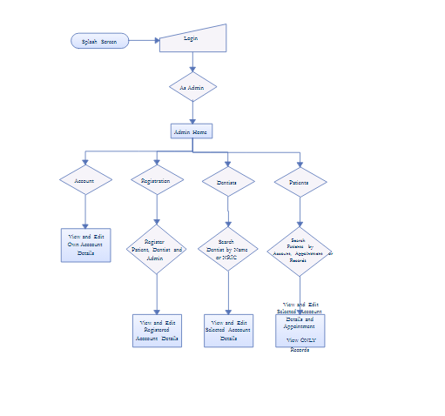

**IMPLEMENTATION DETAILS**

**User Experience:**

* Intuitive Interface:
  + Create an interface that is easy to use, with obvious navigation and visual hints.
  + Take into account a range of technological capabilities and user needs.
  + Offer thorough directions and support at every stage of the procedure.
* Personalization:
  + Permit users to start a fresh discussion and, if necessary, erase the previous conversion.
  + Provide individualized advice based on personal health data and indicate the likelihood of other illnesses.
  + The response may be generated again at the user's convenience
* Treatment Suggestion:
  + Provide the greatest treatment alternatives in accordance with guidelines and best practices.
  + Take into account any possible drug interactions as well as patient-specific variables (cough, headache, fever, allergies, and common cold).
* Accessibility:
  + Make sure that users with disabilities may utilize assistive technology.
  + Facilitates voice search and text-based communication.

**Software Requirements:**

* Programming Languages: Html, CSS, JavaScript, PHP
* Database: DBMS.

**Hard Requirements:**

* Windows 10, 64-bit OS
* 8gb Ram and 512 SSD
* Intel i5 processor
* Mobile device (smartphone/ tablet).

# CHAPTER-7

# TIMELINE FOR EXECUTION OF PROJECT

# (GANTT CHART)

* **Review 0**
  + **Title Finalization with Supervisor**: Meet with your project supervisor to discuss and finalize the project's title. This step ensures that you and your supervisor are aligned on the project's focus.
  + **Literature Survey**: Start researching relevant literature in your field. This involves reading academic papers, articles, and books related to your topic. The literature survey helps you understand the existing research in the area.
  + **Finalizing Objectives**: Define the specific objectives and goals of your project. What do you aim to achieve? What problems are you trying to solve?
  + **Deciding the Methodology**: Determine the research methodology you'll use in your project, whether it's experimental, survey-based, analytical, or a combination of methods.
* **Review 1**
  + **Title**: After finalizing with your supervisor, formally decide on and document the project title.
  + **Abstract:** Write the project abstract, a concise summary of your project's purpose, methodology, and expected outcomes.
  + **Literature Survey**: Continue your literature survey and ensure that you've referred to at least one research paper in your work.
  + **Identify**: The advantages and the disadvantages of our project.
  + **Software and Framework Details**: List the software framework tools or platforms you plan to use.
  + **References**: Site all the sources you've used in your literature survey.

* **Review 2**
  + **Source Code Details:** Document your source code, including explanations and comments.
  + **50% Implementation Details with Live Demo:** Implement at least half of your project and present a live demonstration.
  + **50% Report Softcopy:** Submit a softcopy of the project report with 50% completion
* **Review 3**
  + **Source Code Details**: Continue documenting and explaining your source code.
  + **50% Implementation Details with Live Demo**: Complete 75% of the project implementation and demonstrate it live.
  + **75% Report Softcopy**: Submit a softcopy of the project report with 75% completion.
  + **75% Report Softcopy**: Submit an updated softcopy of the project report with 75% of the content.
* **Final submission**
  + **Final Report and Submission of Project**: Complete your project, finalize the report, and submit the final project and report to your supervisor or institution.
  + Complete implementation details with live demo.
  + Submitting the final report to the reviewer.

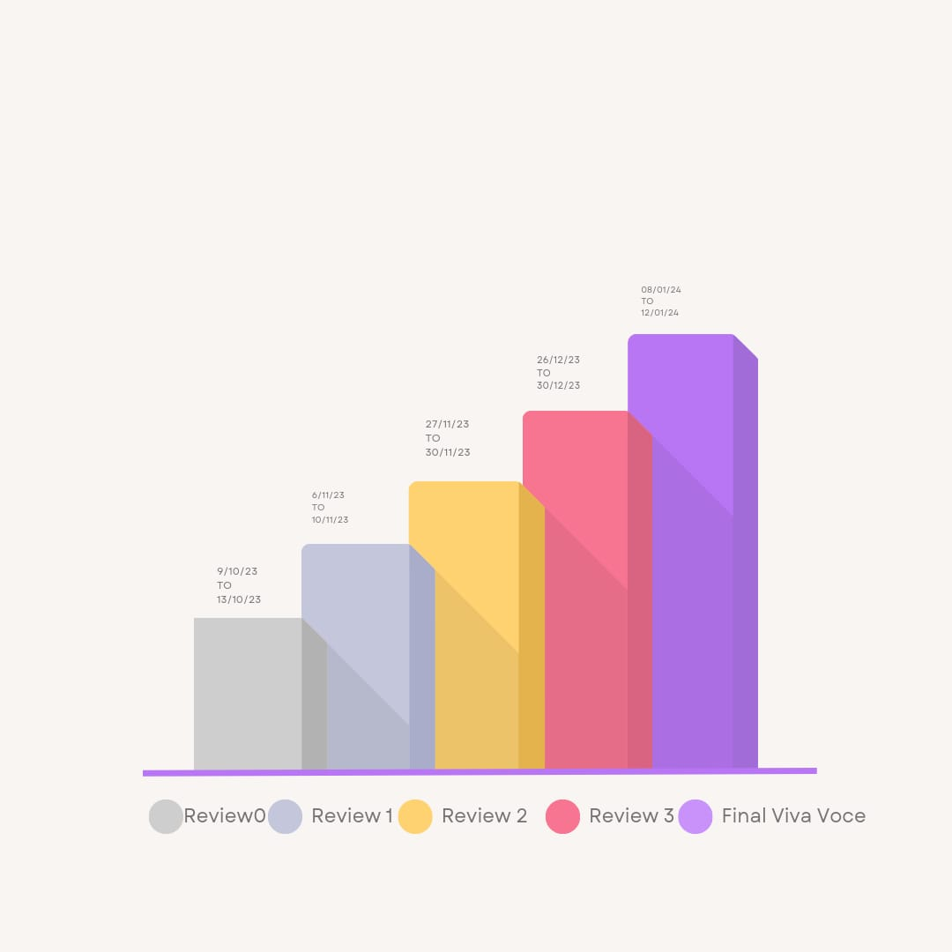

**CHAPTER-8**

**OUTCOMES**

Patients get access to their own health data through healthcare portals. Portals can help patients find medical providers more conveniently and also encourage users to adopt healthier habits. However, mobile apps present a unique challenge: how to keep users engaged.

Health applications have the potential to save costs, provide transparency into treatment success, and generate more engaged, empowered healthcare customers.

The healthcare sector is quickly transforming as a result of digital transformation, from early disease detection to remote and continuous patient monitoring to treatment management. IoT, AI/ML, cloud computing, mobility, and analytics are key emerging technologies in this shift.

The global mHealth solutions market is estimated to increase at a CAGR of 33.3% from $50.8 billion in 2020 to $213.60 billion in 2025, according to Markets and Markets. This surge has been fueled by increased mobile penetration, decreased patient visits due to the COVID-19 epidemic, and the availability of 4G/5G internet in rural regions.

mHealth portal are classified according to their applications and consumers. They are extremely beneficial to both patients and doctors. Teleconsultation, remote patient monitoring, and medication and treatment adherence are examples of portal for varied use cases. Let's take a look at how these applications can help patients and doctors with the many capabilities they provide.

Patients get access to their own health data through mobile healthcare apps. Portal can help patients find medical providers more conveniently and also encourage users to adopt healthier habits. However, portal present a unique challenge: how to keep users engaged.

Health applications have the potential to save costs, provide transparency into treatment success, and generate more engaged, empowered healthcare customers.

The healthcare sector is quickly transforming as a result of digital transformation, from early disease detection to remote and continuous patient monitoring to treatment management. IoT, AI/ML, cloud computing, mobility, and analytics are key emerging technologies in this shift.

The global mHealth solutions market is estimated to increase at a CAGR of 33.3% from $50.8 billion in 2020 to $213.60 billion in 2025, according to Markets and Markets. This surge has been fueled by increased mobile penetration, decreased patient visits due to the COVID-19 epidemic, and the availability of 4G/5G internet in rural regions. mHealth portal are classified according to their applications and consumers. They are extremely beneficial to both patients and doctors.

Teleconsultation, remote patient monitoring, and medication and treatment adherence are examples of portal for varied use cases. Let's take a look at how these applications can help patients and doctors with the many capabilities they provide.

Patients get access to their own health data through mobile healthcare portal. Portals can help patients find medical providers more conveniently and also encourage users to adopt healthier habits. However, mobile portal presents a unique challenge: how to keep users engaged.

Health applications have the potential to save costs, provide transparency into treatment success, and generate more engaged, empowered healthcare customers.

The healthcare sector is quickly transforming as a result of digital transformation, from early disease detection to remote and continuous patient monitoring to treatment management. IoT, AI/ML, cloud computing, mobility, and analytics are key emerging technologies in this shift.

The global mHealth solutions market is estimated to increase at a CAGR of 33.3% from $50.8 billion in 2020 to $213.60 billion in 2025, according to Markets and Markets. This surge has been fueled by increased mobile penetration, decreased patient visits due to the COVID-19 epidemic, and the availability of 4G/5G internet in rural regions.

mHealth portal are classified according to their applications and consumers. They are extremely beneficial to both patients and doctors. Teleconsultation, remote patient monitoring, and medication and treatment adherence are examples of apps for varied use cases. Let's take a look at how these applications can help patients and doctors with the many capabilities they provide.

# CHAPTER-9

# RESULTS AND DISCUSSIONS

The examination of the several components mentioned above showed that, depending on the level of competence of a group of healthcare managers, healthcare management varies from nation to nation. Modern surgery, the discovery of antibiotics, and the introduction of medicines and other pharmaceuticals are all commonplace in many nations.

As stated by Ketelhöhn & Sanz (2016), the national framework for healthcare management raises the bar for professional management, establishes standards for healthcare management, and includes a monitor function to make sure that healthcare staff follow the established standards. This framework ensures that there is a link between educational institutions and competent healthcare managers by providing the educational path for graduate levels in healthcare management through the national framework. Last but not least, Ginter et al. (2018) claim that the national framework supports professional collaborations that uphold and accelerate the field's progress. According to research like that done by McMullen et al. (2014), the majority of large healthcare institutions have interesting sizes. In a facility this size, there are a plethora of tasks and responsibilities beyond just medical care. Among many other things, there are tasks related to accounting, security, management, nursing, treating, and training. As a result, in addition to being medical facilities, hospitals and clinics also serve as spaces for social and commercial activities. This indicates that an administrator who is qualified and experienced in carrying out their duties is needed to provide the guidance and coordination that these kinds of institutions demand. They possess the ability to comprehend a wide range of professional, financial, and social contexts related to the administration of these kinds of organizations. A competent manager is also necessary for some of the larger organizations' financial and budgetary infusions. Furthermore, the majority of these healthcare institutions' executives and trustees demand that the established standards be successfully upheld to ensure the safety of the services and the proper treatment of the patients.

# CHAPTER-10

# CONCLUSION

Over the past ten years, mobile health has gained a lot of attention as a global phenomenon. mHealth is a rapidly developing field that uses devices, software, and mobile technology to assist individuals in achieving their health objectives. Global health service delivery may change if mobile and wireless technologies are adopted in the medical field. This change is the result of several achievements, including the quick development of mobile networks and applications, the growing trend of incorporating mobile health solutions into institutional health systems, and more funding, regulation, and empirical data.

Technology advancements have greatly expanded the potential of mobile health. Smartphones and tablets are transforming the way we utilize mobile devices for health management with features like a high-resolution camera, GPS, and embedded sensors that offer greater capabilities than a laptop or desktop.

Systemic lupus erythematosus and rheumatoid arthritis are probably typical of a wide range of chronic illnesses that may eventually take over the U.S. health care system. Integrated research and longitudinal studies are necessary to fully understand the care systems for chronic diseases like SLE and RA, even with the inherent constraints posed by shifting health care practices, patient and physician characteristics, population demographics, and financial constraints.

# REFERENCES

1. [(PDF) mHealth taxonomy: a literature survey of mobile health applications (researchgate.net)](https://www.researchgate.net/publication/276099168_mHealth_taxonomy_a_literature_survey_of_mobile_health_applications)
2. [Mobile Devices and Apps for Health Care Professionals: Uses and Benefits - PMC (nih.gov)](https://www.ncbi.nlm.nih.gov/pmc/articles/PMC4029126/)
3. [Healthcare Application Development Guide - TatvaSoft Blog](https://www.tatvasoft.com/outsourcing/2022/05/healthcare-application-development.html)
4. typeset.io/papers/medical-smartphone-applications-a-new-and-innovative-way-to-28fazveh7j
5. The_Past_Present_and_Future_of_the_Healthcare_Delivery_System_Through_Digitalization.pdf
6. <https://www.researchgate.net/publication/258206008_A_New_proposed_Software_Engineering_Methodology_For_Healthcare_Applications_Development>
7. <https://techexactly.com/blogs/healthcare-application-development-guide-types-features-challenges>
8. <https://techexactly.com/blogs/healthcare-application-development-guide-types-features-challenges>

# APPENDIX-A PSEUDOCODE

**Menu.js**

jQuery(function () {

'use strict';

document.addEventListener("touchstart", function () {}, false);

jQuery(function () {

jQuery('body').wrapInner('<div class="wsmenucontainer" />');

jQuery('<div class="overlapblackbg"></div>').prependTo('.wsmenu');

jQuery('#wsnavtoggle').click(function () {

jQuery('body').toggleClass('wsactive');

});

jQuery('.overlapblackbg').click(function () {

jQuery("body").removeClass('wsactive');

});

jQuery('.wsmenu > .wsmenu-list > li').has('.sub-menu').prepend('<span class="wsmenu-click"><i class="wsmenu-arrow"></i></span>');

jQuery('.wsmenu > .wsmenu-list > li').has('.wsmegamenu').prepend('<span class="wsmenu-click"><i class="wsmenu-arrow"></i></span>');

jQuery('.wsmenu-click').click(function () {

jQuery(this).toggleClass('ws-activearrow')

.parent().siblings().children().removeClass('ws-activearrow');

jQuery(".wsmenu > .wsmenu-list > li > .sub-menu, .wsmegamenu").not(jQuery(this).siblings('.wsmenu > .wsmenu-list > li > .sub-menu, .wsmegamenu')).slideUp('slow');

jQuery(this).siblings('.sub-menu').slideToggle('slow');

jQuery(this).siblings('.wsmegamenu').slideToggle('slow');

});

jQuery('.wsmenu > .wsmenu-list > li > ul > li').has('.sub-menu').prepend('<span class="wsmenu-click02"><i class="wsmenu-arrow"></i></span>');

jQuery('.wsmenu > .wsmenu-list > li > ul > li > ul > li').has('.sub-menu').prepend('<span class="wsmenu-click02"><i class="wsmenu-arrow"></i></span>');

jQuery('.wsmenu-click02').click(function () {

jQuery(this).children('.wsmenu-arrow').toggleClass('wsmenu-rotate');

jQuery(this).siblings('li > .sub-menu').slideToggle('slow');

});

jQuery(window).on('resize', function () {

if (jQuery(window).outerWidth() < 992) {

jQuery('.wsmenu').css('height', jQuery(this).height() + "px");

jQuery('.wsmenucontainer').css('min-width', jQuery(this).width() + "px");

} else {

jQuery('.wsmenu').removeAttr("style");

jQuery('.wsmenucontainer').removeAttr("style");

jQuery('body').removeClass("wsactive");

jQuery('.wsmenu > .wsmenu-list > li > .wsmegamenu, .wsmenu > .wsmenu-list > li > ul.sub-menu, .wsmenu > .wsmenu-list > li > ul.sub-menu > li > ul.sub-menu, .wsmenu > .wsmenu-list > li > ul.sub-menu > li > ul.sub-menu > li > ul.sub-menu').removeAttr("style");

jQuery('.wsmenu-click').removeClass("ws-activearrow");

jQuery('.wsmenu-click02 > i').removeClass("wsmenu-rotate");

}

});

jQuery(window).trigger('resize');

});

}());

**Admin.php**

<html lang="en">

<?php include("php_include/head.php")?>

<body>

<div id="loader-wrapper">

<div id="loader">

<div class="loader-inner"></div>

</div>

</div>

<div id="page" class="page">

<header id="header" class="header" >

<div class="wsmainfull menu clearfix" >

<div class="wsmainwp clearfix" >

<div class="desktoplogo"><a href="#hero-2"><img src="images/text-1702913677293.png" width="300" height="40" alt="header-logo"></a></div>

<nav class="wsmenu clearfix">

<ul class="wsmenu-list">

<li aria-haspopup="true">

<a href="admin_register.php"><font size="4">Register & View Members</font></a>

</li>

<li aria-haspopup="true">

<a href="admin_logout.php"><font size="4">Logout</font></a>

</li>

</ul>

</nav>

</div>

</div>

</header>

<section id="hero-2" class="hero-section division">

<div class="slider blue-nav">

<ul class="slides">

<li id="slide-1">

<img src="images/slide1.jpg" alt="slide-background">

<div class="caption d-flex align-items-center left-align">

<div class="container">

<div class="row">

<div class="col-md-9 col-lg-7">

<div class="caption-txt">

<h2 class="white-color">Welcome To<br> <span class="white-color">Admin Page</span></h2>

</div>

</div>

</div>

</div>

</div>

</li>

</ul>

</div>

</section>

</div>

**Doctor.php**

<?php

$query=mysqli_query($con,"SELECT * FROM doctor WHERE doctor_id='$doctor_id'");

$row=mysqli_fetch_array($query);

?>

<center> <h3>Greetings : <?php echo $row['doctor_id']; ?> </h3></center>

<br>

<center>

<?php

$query=mysqli_query($con,"SELECT * FROM doctor WHERE doctor_id='$doctor_id'");

$row=mysqli_fetch_array($query);

$doctor_id=$row['doctor_id'];

$my_password=$row['password'];

$department=$row['department'];

$my_password=$row['password'];

$designation=$row['designation'];

$speciality=$row['speciality'];

$hospital_id=$row['hospital_id'];

$name=$row['name'];

?>

<div class="col-md-6 grid-margin stretch-card" >

<div class="card tale-bg" style="padding:20px ;background-color:rgba(255, 106, 89, 0.1);border-radius:20px;border-color:black;box-shadow: 0 4px 8px 0 rgba(0, 0, 0, 0.2), 0 6px 20px 0 rgba(0, 0, 0, 0.19);color:black;font-size:23px;">

<br>

<center><h3>Personal Information</h3></center><br>

<center><b>Name:<?php echo $name;?></b><br>

<b>Hospital ID:<?php echo $hospital_id; ?></b><br>

<b>Department:<?php echo $department; ?></b><br>

<b>Designation:<?php echo $designation; ?></b><br>

<b>Speciality:<?php echo $speciality; ?></b><br></center>

<hr>

<br>

</div>

</div>

</center><br>

<center>

<div class="col-md-6 grid-margin stretch-card" >

<div class="card tale-bg" style="padding:20px ;background-color:rgba(255, 106, 89, 0.1);border-radius:20px;border-color:black;box-shadow: 0 4px 8px 0 rgba(0, 0, 0, 0.2), 0 6px 20px 0 rgba(0, 0, 0, 0.19);color:black;font-size:23px;">

<br>

<center><h3>Contact Information</h3></center><br>

<center><b>Address:<?php echo $row['address'];?></b><br>

<b>Contact No:<?php echo $row['contact'];?></b><br>

<b>Email:<?php echo $row['email'];?></b><br>

</center>

<hr>

<br>

<center>

<button type="button"class="btn btn-outline-primary" style="padding:15px;border-color:black;width:15%;"><a href="edit_doctor.php"><b><font color="black" size="4" >Edit</font></b></a></button></center>

</div>

</div>

</center><br><br>

</div>

<script src="js/jquery-3.3.1.min.js"></script>

<script src="js/bootstrap.min.js"></script>

<script src="js/modernizr.custom.js"></script>

<script src="js/jquery.easing.js"></script>

<script src="js/jquery.appear.js"></script>

<script src="js/jquery.stellar.min.js"></script>

<script src="js/menu.js"></script>

<script src="js/sticky.js"></script>

<script src="js/jquery.scrollto.js"></script>

<script src="js/materialize.js"></script>

<script src="js/owl.carousel.min.js"></script>

<script src="js/jquery.magnific-popup.min.js"></script>

<script src="js/imagesloaded.pkgd.min.js"></script>

<script src="js/isotope.pkgd.min.js"></script>

<script src="js/hero-form.js"></script>

<script src="js/contact-form.js"></script>

<script src="js/comment-form.js"></script>

<script src="js/appointment-form.js"></script>

<script src="js/jquery.datetimepicker.full.js"></script>

<script src="js/jquery.validate.min.js"></script>

<script src="js/jquery.ajaxchimp.min.js"></script>

<script src="js/wow.js"></script>

<script src="js/custom.js"></script>

<script>

new WOW().init();

</script>

<script src="js/changer.js"></script>

<script defer src="js/styleswitch.js"></script>

</body>

</html>

**Patient.php**

<?php

$query=mysqli_query($con,"SELECT * FROM patient WHERE patient_id='$patient_id'");

$row=mysqli_fetch_array($query);

?>

<center> <h3>Greetings : <?php echo $row['patient_id']; ?> </h3></center>

<br>

<center>

<?php

$query=mysqli_query($con,"SELECT * FROM patient WHERE patient_id='$patient_id'");

$row=mysqli_fetch_array($query);

$patient_id=$row['patient_id'];

$hospital_id=$row['hospital_id'];

$gender=$row['gender'];

$my_password=$row['password'];

$name=$row['patient_name'];

$dob=$row['dob'];

$disease=$row['disease'];

$treatement=$row['treatement'];

$name=$row['patient_name'];

?>

<div class="col-md-6 grid-margin stretch-card" >

<div class="card tale-bg" style="padding:20px ;background-color:rgba(255, 106, 89, 0.1);border-radius:20px;border-color:black;box-shadow: 0 4px 8px 0 rgba(0, 0, 0, 0.2), 0 6px 20px 0 rgba(0, 0, 0, 0.19);color:black;font-size:23px;">

<br>

<center><h3>Personal Information</h3></center><br>

<center><b>Name:<?php echo $name;?></b><br>

<b>Hospital ID:<?php echo $hospital_id; ?></b><br>

<b>Gender:<?php echo $gender; ?></b><br>

<b>Date Of Birth:<?php echo $dob; ?></b><br>

<b>Disease:<?php echo $disease; ?></b><br>

<b>Treatment:<?php echo $treatement; ?></b><br>

<b>Medicine:<?php echo $row['medicine']; ?></b><br>

</center>

<hr>

<br>

</div>

</div>

</center><br>

<center>

<div class="col-md-6 grid-margin stretch-card" >

<div class="card tale-bg" style="padding:20px ;background-color:rgba(255, 106, 89, 0.1);border-radius:20px;border-color:black;box-shadow: 0 4px 8px 0 rgba(0, 0, 0, 0.2), 0 6px 20px 0 rgba(0, 0, 0, 0.19);color:black;font-size:23px;">

<br>

<center><h3>Contact Information</h3></center><br>

<center><b>Address:<?php echo $row['address'];?></b><br>

<b>Contact No:<?php echo $row['contact'];?></b><br>

<b>Email:<?php echo $row['email'];?></b><br>

</center>

<hr>

<br>

<center> <button type="button"class="btn btn-outline-primary" style="padding:15px;border-color:black;width:15%;"><a href="edit_patient.php"><b><font color="black" size="4" >Edit</font></b></a></button></center>

</div>

</div>

</center><br><br>

</div>

<script src="js/jquery-3.3.1.min.js"></script>

<script src="js/bootstrap.min.js"></script>

<script src="js/modernizr.custom.js"></script>

<script src="js/jquery.easing.js"></script>

<script src="js/jquery.appear.js"></script>

<script src="js/jquery.stellar.min.js"></script>

<script src="js/menu.js"></script>

<script src="js/sticky.js"></script>

<script src="js/jquery.scrollto.js"></script>

<script src="js/materialize.js"></script>

<script src="js/owl.carousel.min.js"></script>

<script src="js/jquery.magnific-popup.min.js"></script>

<script src="js/imagesloaded.pkgd.min.js"></script>

<script src="js/isotope.pkgd.min.js"></script>

<script src="js/hero-form.js"></script>

<script src="js/contact-form.js"></script>

<script src="js/comment-form.js"></script>

<script src="js/appointment-form.js"></script>

<script src="js/jquery.datetimepicker.full.js"></script>

<script src="js/jquery.validate.min.js"></script>

<script src="js/jquery.ajaxchimp.min.js"></script>

<script src="js/wow.js"></script>

<script src="js/custom.js"></script>

<script>

new WOW().init();

</script>

<script src="js/changer.js"></script>

<script defer src="js/styleswitch.js"></script>

</body>

</html>

**APPENDIX-B SCREENSHOTS**

1. Home page

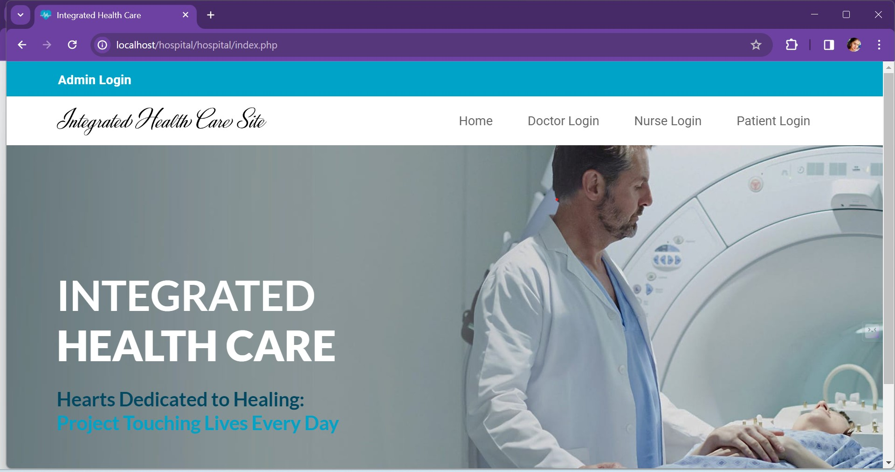

1. Admin login page

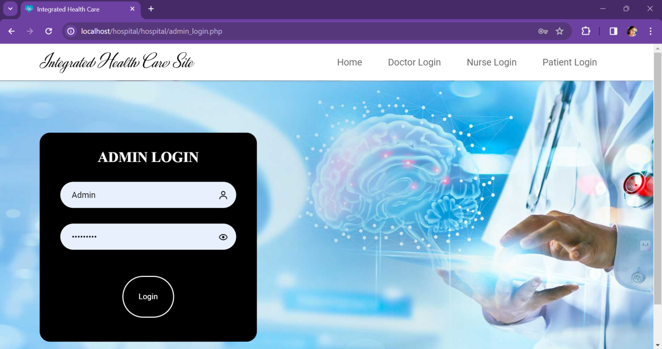

1. Admin login page code

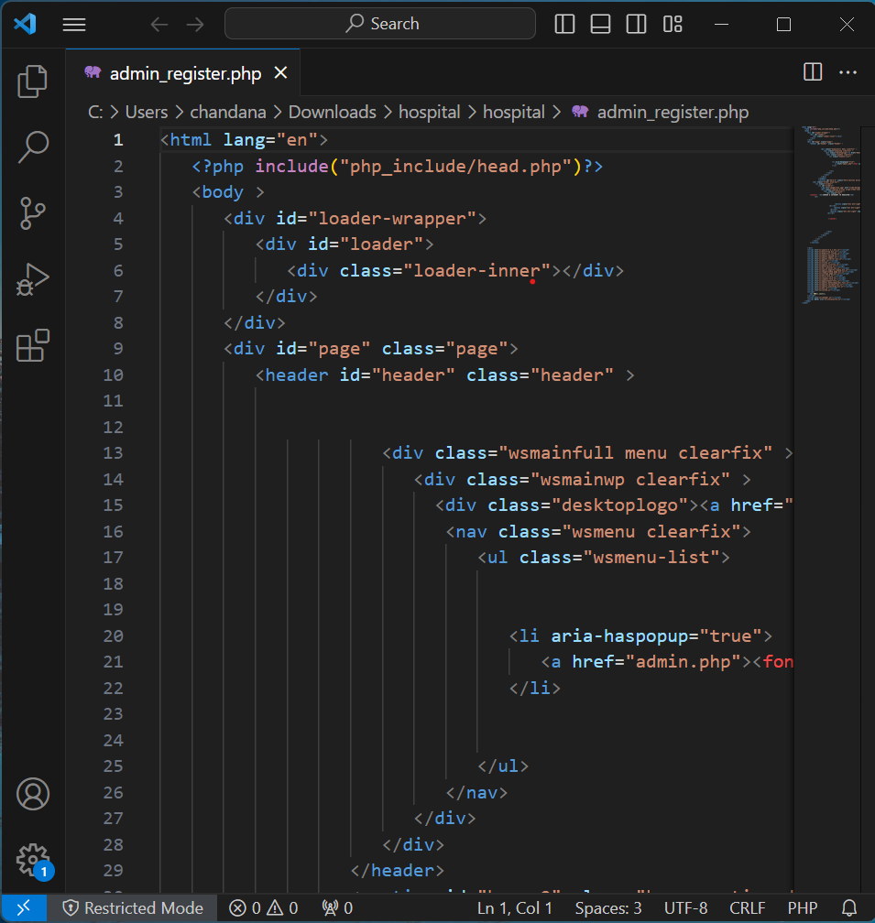

4.Admin logout page

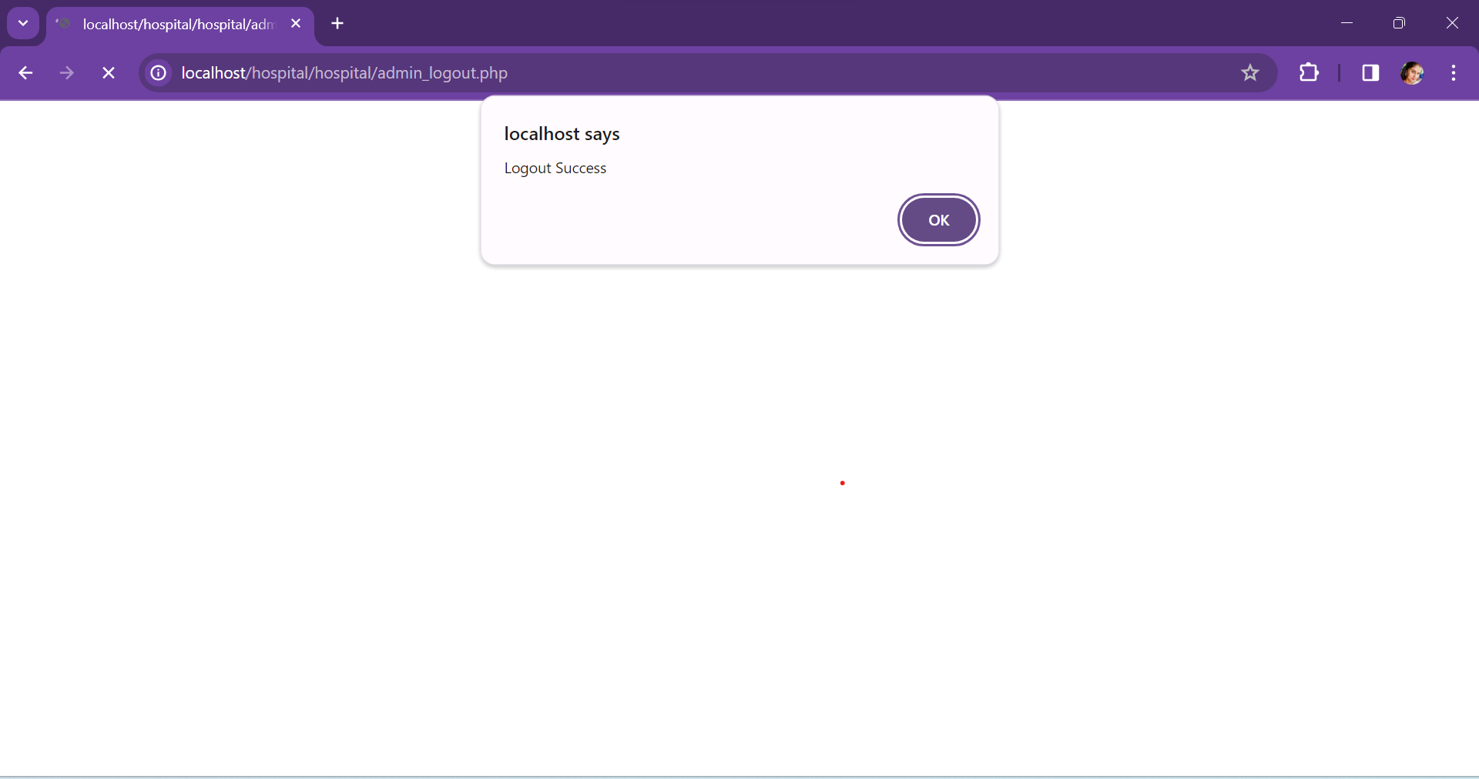

5.Admin logout page code

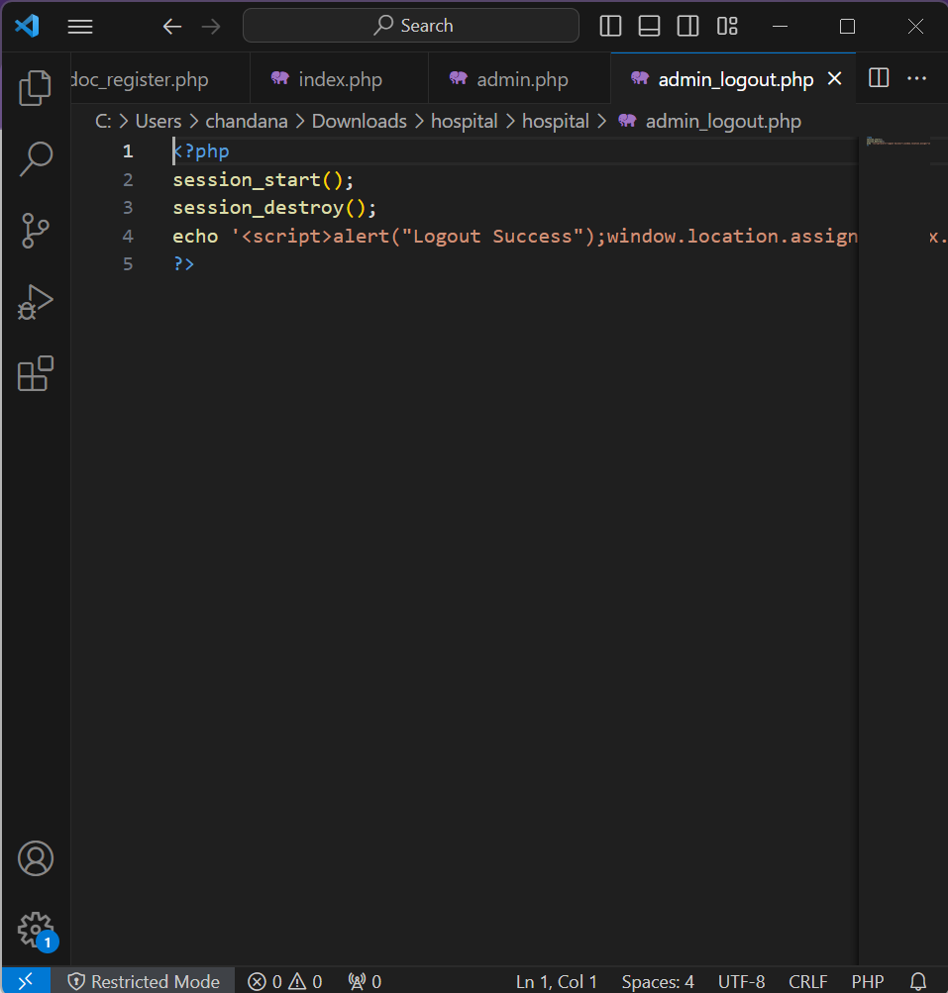

6. Doctor login page

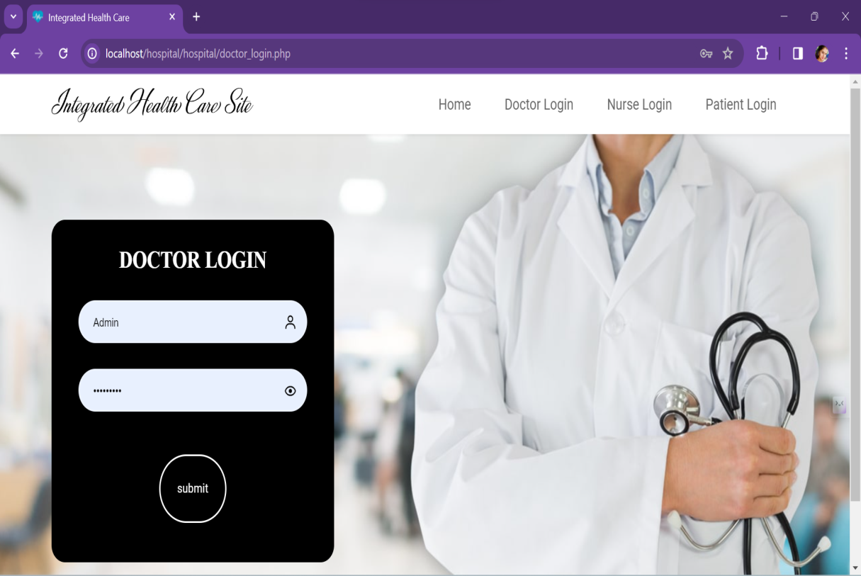

1. Doctor login page code

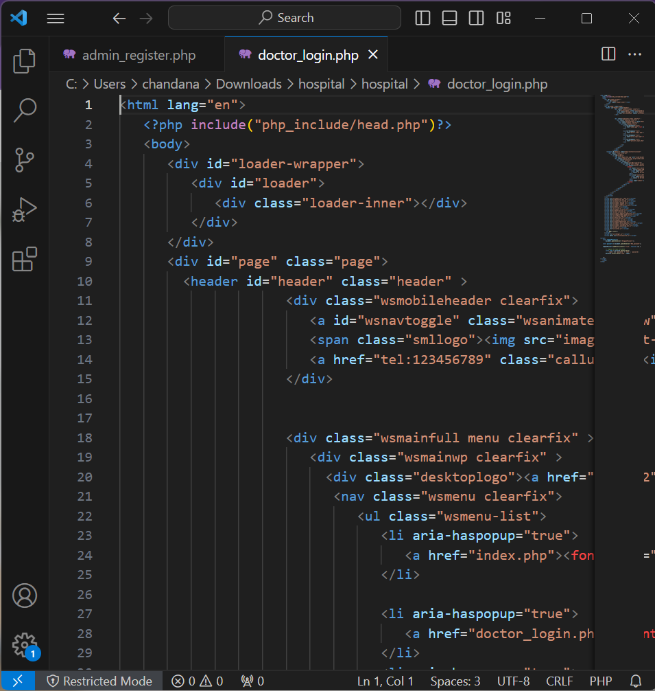

1. Hospital records page

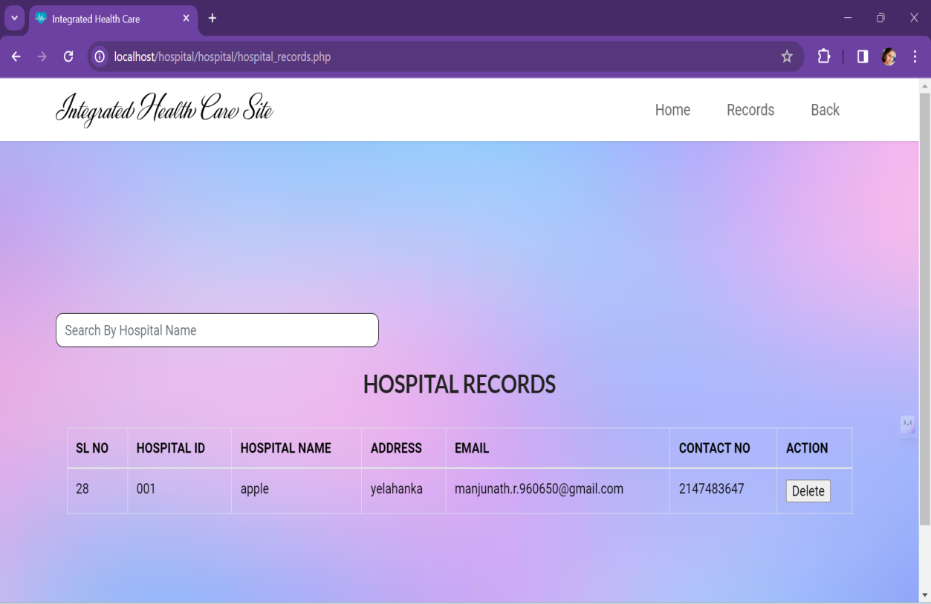

9.Hospital records page code

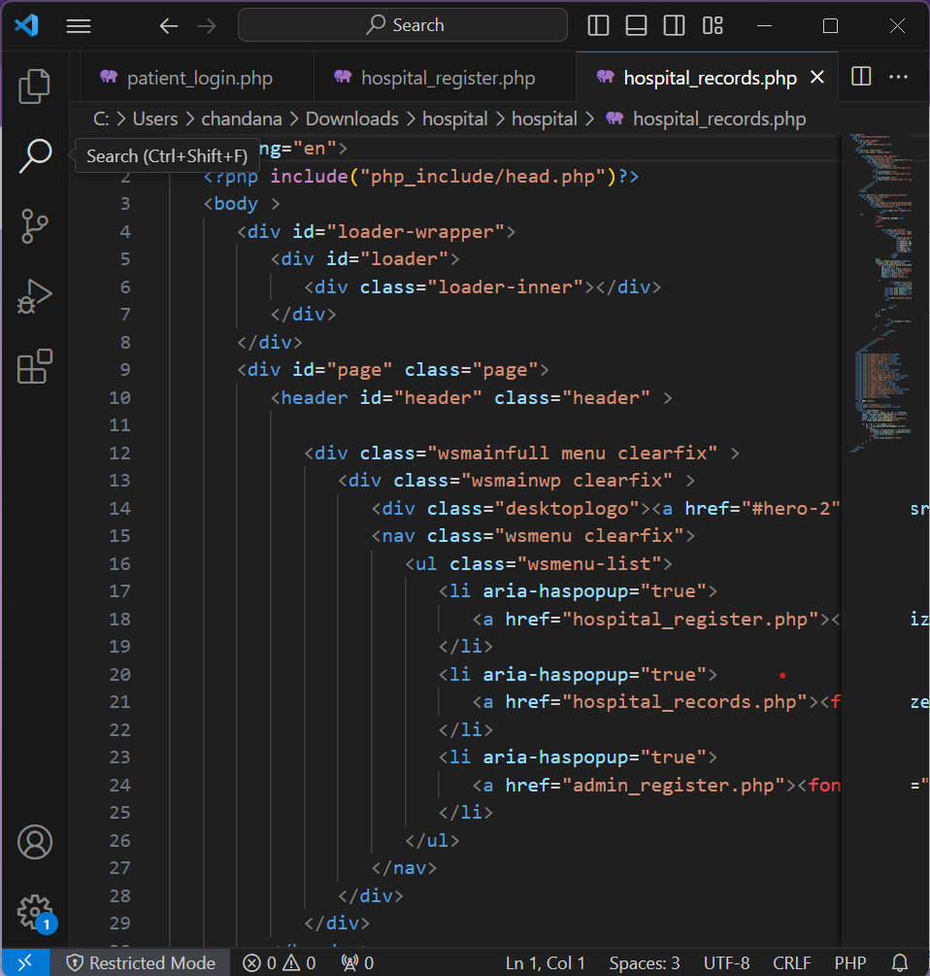

10.Hospital registration form page

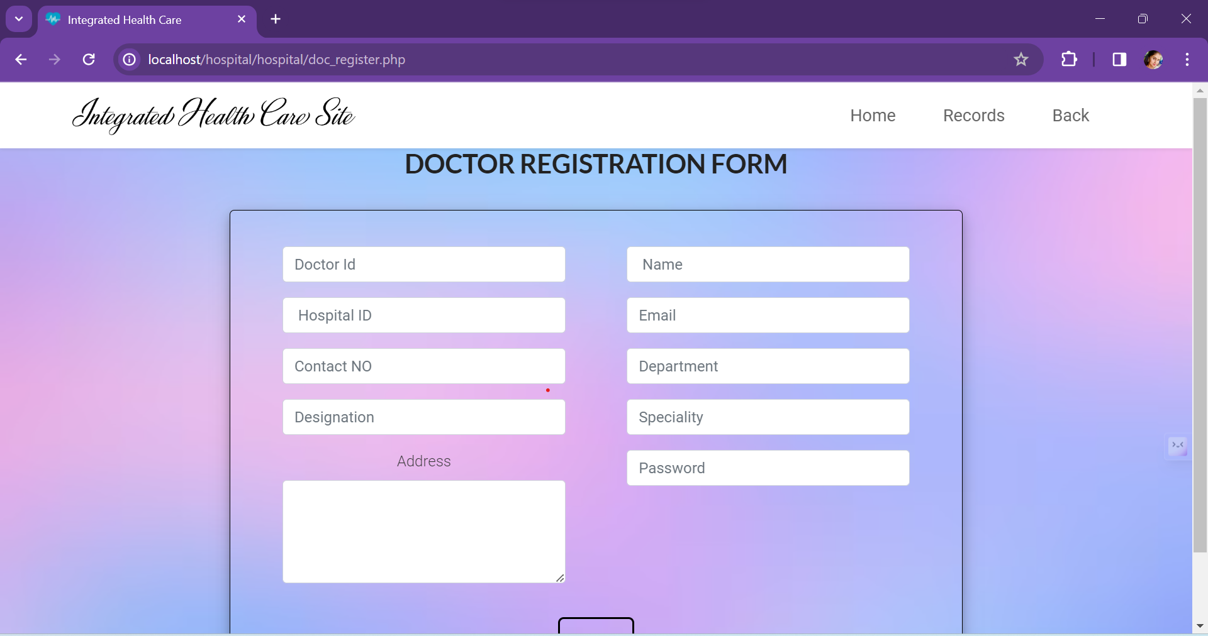

11.Hospital registration form code

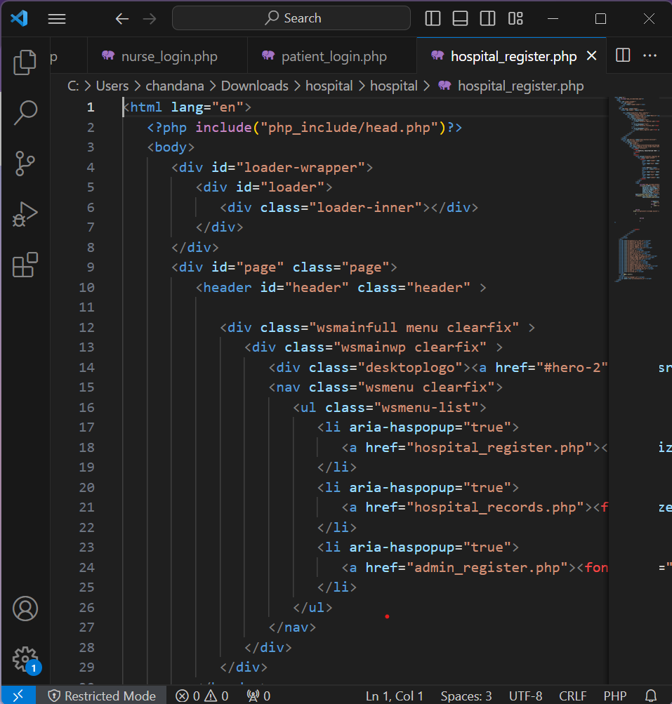

12. Nurse login page

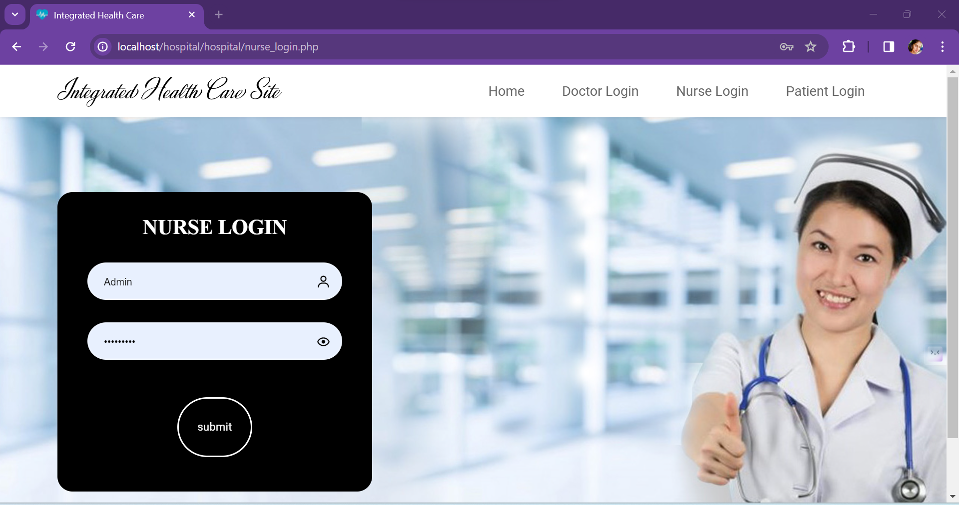

13.Nurse login page code

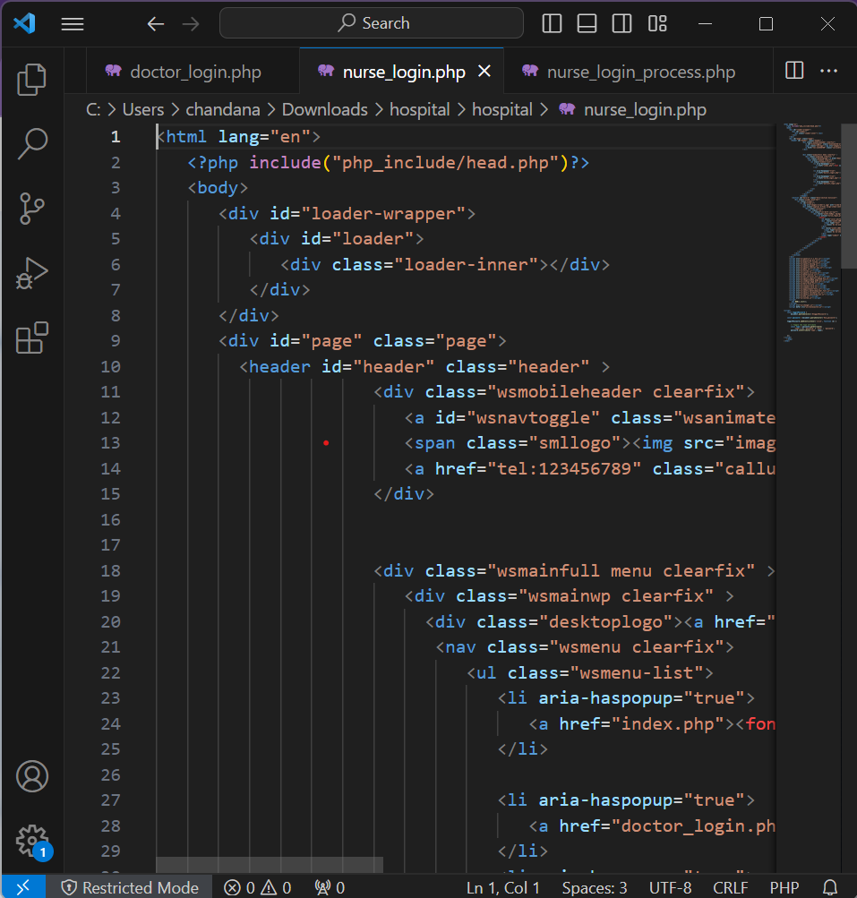

14. Nurse records page

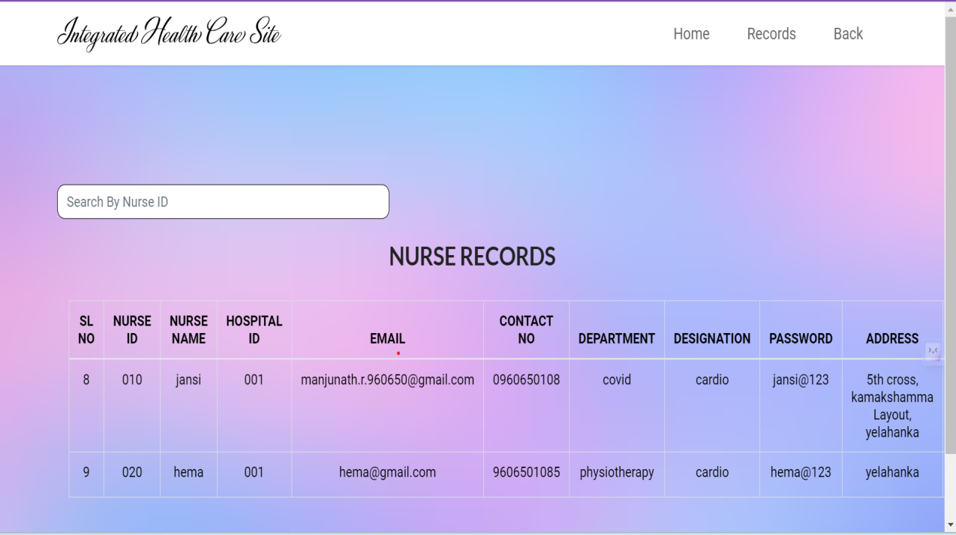

15. Nurse records page code

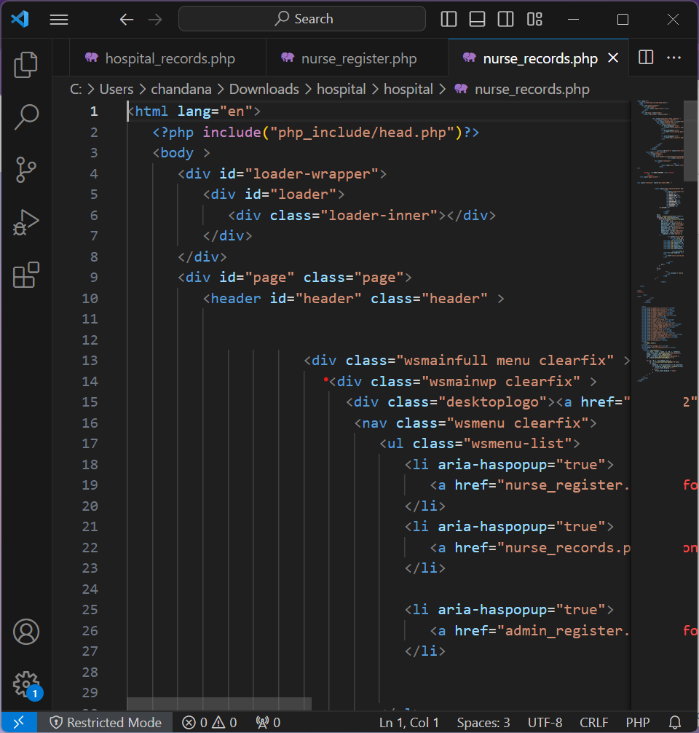

# APPENDIX-C ENCLOSURES

1. **Conference Paper Presented Certificates of all students.**

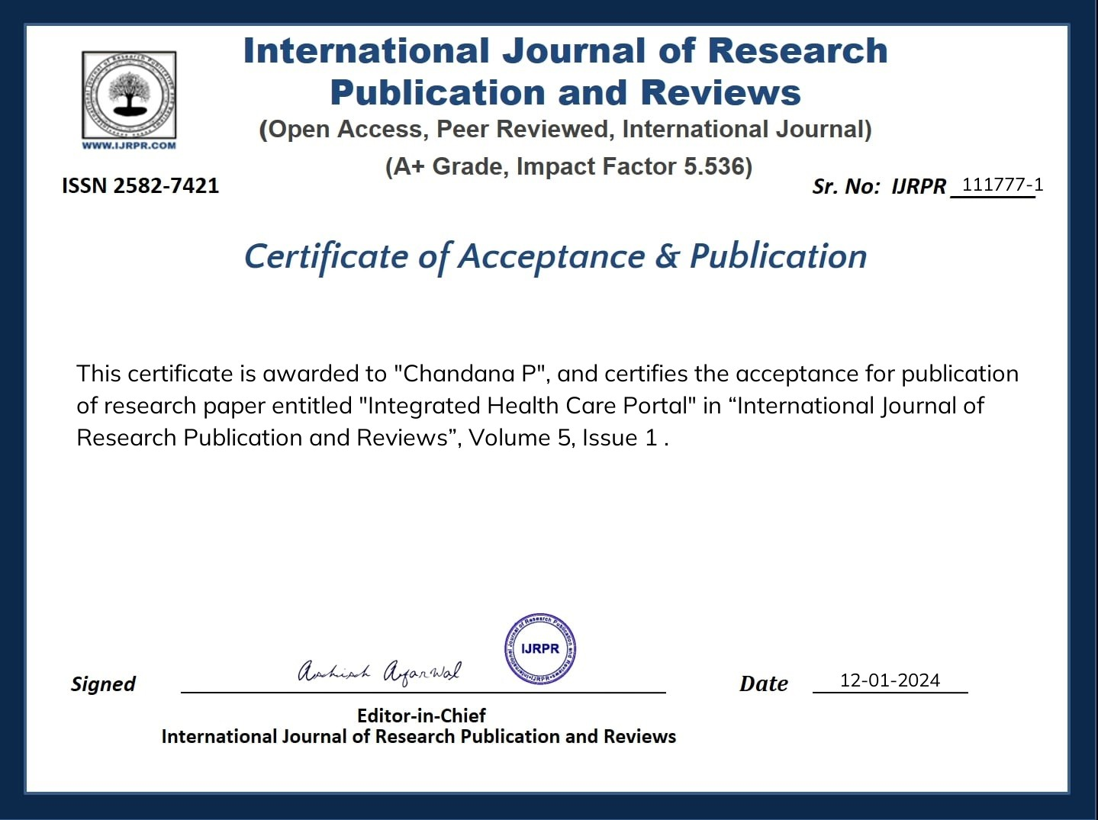

# 

# 

# 

# 

1. **Similarity Index / Plagiarism Check report clearly showing the Percentage (%). No need for a page-wise explanation.**

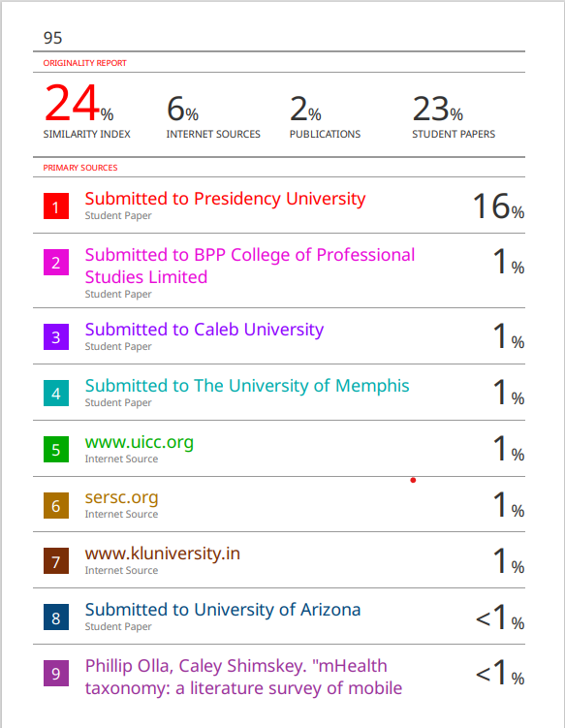

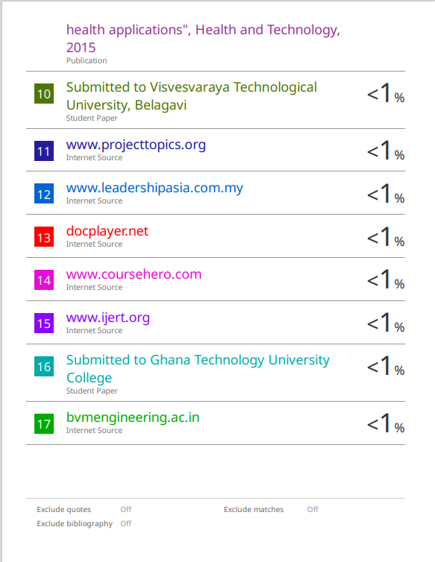

**SUSTAINABLE GOALS DEVELOPMENT**

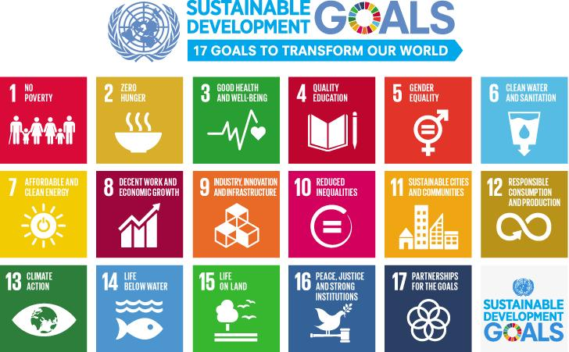

**The project work carried out here is mapped to SDG-3 Good Health And Well-Being.**

The project work carried have contributes to the well-being of the human society. This can be used by various users such doctors, patients, nurse, administrators, hospitals for better communication and more efficiency, they can keep records such as medications, treatments and more, which can be used for future purpose.